Birthday Menu Choices
    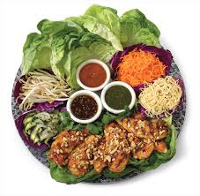  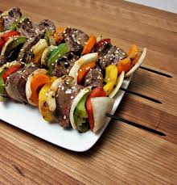 |  | Make Your Own Pizza  - Toasted Whole-Grain Cheese Bread  - Crunchy Veggies and Creamy Herb Dip  Baked Parmesan Chicken Fingers  - French Fries  - Garden Fresh Salad  Shrimp Scampi  - Caesar Salad  - Crusty Baguette  Whole Wheat Turkey Lasagna  - Twisty Sticks  - Marinated Cucumber and Tomato Basil Salad  Lettuce Chicken Wraps  - Baked Fried Rice  - Asian Coleslaw with Sesame Dressing  Sirloin Steak Kebabs  - Whole Baked Potatoes  - Steamed Green Beans

